Zombie Outbreak
Each day, a zombie infects 2 new people | Each day, the zombie learns how to infect 2 more people than they did the previous day before | Each day every Zombie Infects someone new

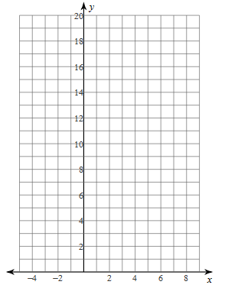
Equation: | Equation: | Equation:
How many Zombies Day 20? | How many zombies day 20? | How many Zombies day 20?
Now, let’s compare the different functions. Graph all 3 functions on the same graph. For purposes of the following questions, connect the points for each graph. Use a different color for each function and label them.
What do each of the functions have in common?

Which function increases at the fastest rate?

When is the linear function larger than the other 2 functions, if ever?

When is the quadratic function larger than the other 2 functions, if ever?

When is the exponential function larger than the other 2 functions, if ever?

When do the functions intersect each other?

Over time, is there one function that is always larger than the other 2 functions? If so, which function is it?

Using each of the models created, determine how many days it will take for the zombies to wipe out ….
Situation | Equation | Equation | Equation
Pebblebrook High School

Atlanta

Georgia

The United States

The world

Compare | Linear | Quadratic | Exponential
Domain
Range
x-int
y-int
Increase
Decrease
End Behavior
Max/Min?
Asymptote

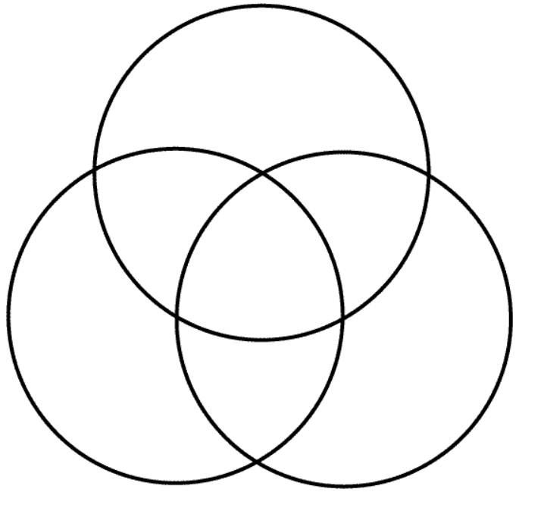
Exponential
Linear
Quadratic

