Characteristics of exponential functions worksheet
Directions:
1. On https://www.desmos.com/calculator graph the following exponential functions.
2. Identify The
- Asymptote
- Domain and Range
- End Behavior
- X Intercepts
- Y Intercepts

1. $f\left(x\right)=4({2)}^{x}$ Asymptote: ____________________
Domain: _______________________
Range: ________________________
End Behavior As f(x) ___________________ x ___________________
F(x)_____________________ x __________________
X Intercepts: ____________________
Y Intercepts: ____________________

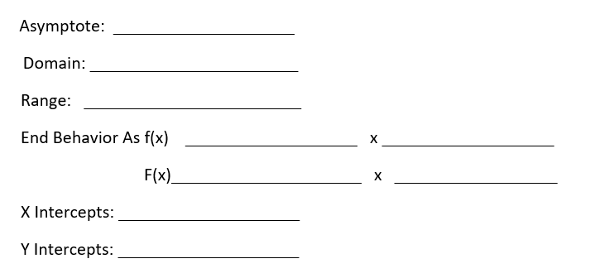
2. $f\left(x\right)= -3 ({4)}^{x}$

3. $f\left(x\right)=4 {\left(\frac{1}{2} \right)}^{x-1}-2$

4. $f\left(x\right)= -3 {\left(2\right)}^{x-2 }+2$

5. $f\left(x\right)=4^{x}+1$

